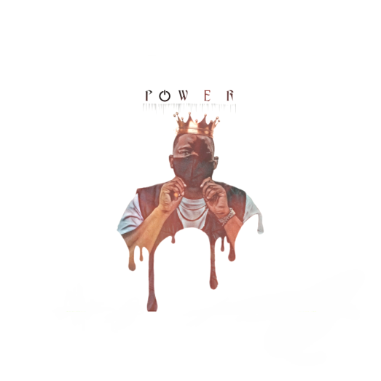

Artist Bio: POWER

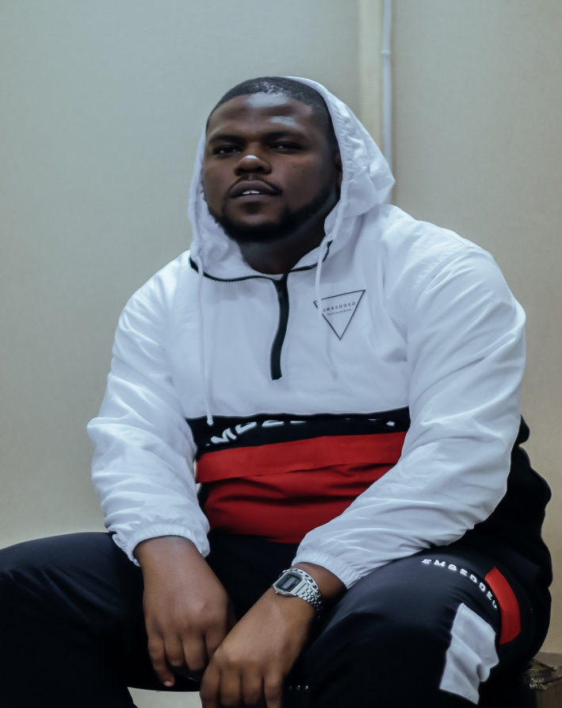

Contact No: +27748640302

Email: [powerisart@gmail.com](mailto:powerisart@gmail.com)

Bookings: [bookingspowerza@gmail.com](mailto:bookingspowerza@gmail.com)

Born 1996,POWER is a South African Rapper/Hip-hop artist ,although he does not like to box himself or his sound he believes he makes music that speaks to him ,no matter what genre it falls under.  
POWER discovered and nurtured his talent for music at the tender age of 11 when he would fill note books with songs that he wrote over songs from other artists as he grew up without access to an production or instrumentals.  
After losing his father in his senior year of high school, he went on to find out that his father used to write music himself but was never a career he pursued which ignited a fire inside him to create and connect with the world around him. His sound is extremely eclectic and his tone allows him to execute this in many forms.

With flows, cadences that bring a fresh sound to music he is pioneering his sound with a combination of Rapping and singing in ways that very few can pull of.

Although born and raised in Polokwane, POWERS sound and dedication was birthed and perfected throughout the years spent in the music scene in Pretoria, along with all its influences.